**Industrial Panel PC**

**QY-P8080**

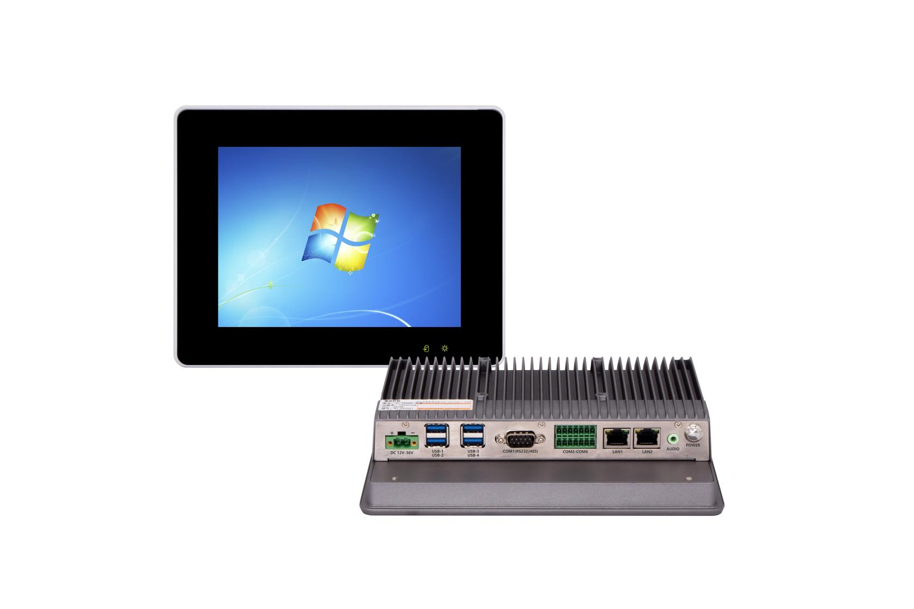

**Products Features:**

1. **Industrial-Grade Embedded Fanless Panel PC**
2. **8 inch LED Screen, Resolution: 800*600**
3. **Support Capacitive and Resistive Touch Screen**
4. **Intel Celeron and Core 4/6/7/8/10th-i3/i5/i7 CPU**
5. **2*RJ-45, 4*USB, 6*COM**
6. **1*Mini PCIE Expansion Slot, Support 4G and WIFI module**
7. **DC 12V Power Input With Overvoltage Protection**
8. **-20℃~50℃ Temperature Can Keep 24/7 Work Stably**
9. **Anti-Static, Anti-Pulse, Anti-Surge, Anti-Radiation**

**QY-P8080**

**1.Mother Board Specification:**

|  |  |  |
| --- | --- | --- |
| **Model** | **QY-P8080** | |
| **CPU** | **J1900**  **i5-4260U** | **N95 / N100 / J6412**  **i3: 7100U**  **i5: 6200U / 7200U / 8260U / 10210U**  **i7: 7500U / 10610U** |
| **Memory** | **1*DDR III RAM Slot, Up to 8GB** | **1*DDR IIII RAM Slot, Up to 16GB** |
| **Storage** | **1*MSATA SSD Slot** | |
| **Expansion** | **1*Mini PCIE Slot, Support 4G and WIFI module** | |
| **Ethernet** | **2*Intel i210v LAN Chip (10 / 100 / 1000 Mbps, RJ-45 Type)** | |
| **USB** | **4*USB 3.0 (Type-A)** | |
| **COM** | **1*RS-232 / 485 (DB9 type)**  **1*RS-232 / 485+4*RS-232 (Phoenix Terminal Type)** | |
| **Audio** | **1*Line-Out** | |

**2.Screen Specification:**

**QY-P8080**

|  |  |  |
| --- | --- | --- |
| **Screen Size** | **8 inch TFT LED Screen, 4:3 Size** | |
| **Resolution** | **800*600** | |
| **Brightness** | **350nits** | |
| **Contrast** | **800:1** | |
| **Largest Colorful** | **16M** | |
| **Touch Screen Type** | **Capacitive** | **Resistive** |
| **Transmittance** | **More than 95%** | **More than 95%** |
| **Touch Life** | **50 million times** | **35 million time** |
| **Response Time** | **＜5ms** | **＜5ms** |
| **Touch Hardness** | **6 Mohs** | |
| **Protection** | **Front Panel IP65 Water Proof** | |

**QY-P8080**

**3.Device Specification:**

|  |  |
| --- | --- |
| **Power Input** | **DC 12V with overvoltage protection**  **(Support optional DC 9-36V Wide Voltage Power Module)** |
| **Support Auto-Start** |
| **2 Pin Phoenix Terminal type DC Plug** |
| **Working Temperature** | **-20℃~60℃, Support 24/7 Working** |
| **Structure** | **Fully Enclosed Aluminum Alloy Material** |
| **Heat Dissipation** | **Fanless Design, Conduction Heat Dissipation** |
| **Installation** | **Desktop / Embedded / Wall Mount** |
| **Size** | **224mm*178mm*53.5mm** |
| **System** | **Windows and Linux** |

**QY-P8080**

**4.Optional Specification:**

|  |  |  |
| --- | --- | --- |
| **Screen** | **Brightness** | **Optional 1000 nits LED screen** |
| **Optional brightness auto adjustment function** |
| **Anti-Glare** | **Optional** |
| **Camera** | **Optional 200w or 500w camera (Built-in front panel)** |
| **Full Lamination** | **Optional** |
| **Resolution** | **Optional 1024*768 LED screen** |

**QY-P8080**

**5.Ordering Information:**

|  |  |  |  |  |  |  |  |  |  |
| --- | --- | --- | --- | --- | --- | --- | --- | --- | --- |
| **Model** | **CPU** | **LAN** | **USB** | **COM** | **RAM** | **Display** | **SSD** | **Expansion** | **Power** |
| **QY-P8080** | **J1900** | **2** | **4** | **2*RS-232/485**  **4*RS-232** | **1*DDR 3**  **Up to 8GB** | **None** | **1*MSATA** | **1*Mini PCIE** | **DC 12V** |
| **4th** |
| **6th / 7th**  **8th / 10th** | **1*DDR 4**  **Up to 16GB** |
| **N95 / N100** | **DC 9-36V** |
| **J6412** | **1*HDMI** | **1*Mini PCIE**  **1*M.2** | **DC 12V** |

**6.System Information:**

|  |  |
| --- | --- |
| **CPU** | **System** |
| **J1900** | **Windows 7 / 10 and Linux** |
| **4th / 6th / 7th** |
| **N95 / N100 / J6412** | **Windows 10 /11 and Linux** |
| **8th / 10th** |

**QY-P8080**

**7.CPU Information:**

|  |  |  |
| --- | --- | --- |
| **CPU** | **Specification** | |
| **J1900** | **4 core, 4 total threads, 2.00 GHz to 2.42GHz, 2 MB cache** | **Max to 8GB for 1*DDR 3 Slot** |
| **i5-4260U** | **2 core, 4 total threads, 1.40 GHz to 2.70GHz, 3 MB cache** | **Max to 8GB for 1*DDR 3 Slot** |
| **N95** | **4 core, 4 total threads, 3.40 GHz, 6 MB cache** | **Max to 16GB for 1*DDR 4 Slot** |
| **N100** | **4 core, 4 total threads, 3.40 GHz, 6 MB cache** | **Max to 16GB for 1*DDR 4 Slot** |
| **J6412** | **4 core, 4 total threads, 2.00 GHz to 2.60GHz, 1.5 MB cache** | **Max to 16GB for 1*DDR 4 Slot** |
| **i5-6200U** | **2 core, 4 total threads, 2.30 GHz to 2.80GHz, 3 MB cache** | **Max to 16GB for 1*DDR 4 Slot** |
| **i3-7100U** | **2 core, 4 total threads, 2.40 GHz, 3MB cache** | **Max to 16GB for 1*DDR 4 Slot** |
| **i5-7200U** | **2 core, 4 total threads, 2.50 GHz to 3.10GHz, 3 MB cache** | **Max to 16GB for 1*DDR 4 Slot** |
| **i7-7500U** | **2 core, 4 total threads, 2.70 GHz to 3.50GHz, 4 MB cache** | **Max to 16GB for 1*DDR 4 Slot** |
| **i5-8260U** | **4 core, 8 total threads, 1.60 GHz to 3.90 GHz, 6MB cache** | **Max to 32GB for 1*DDR 4 Slot** |
| **i5-10210U** | **4 core, 8 total threads, 1.60 GHz to 4.20 GHz, 6MB cache** | **Max to 32GB for 1*DDR 4 Slot** |
| **i7-10610U** | **4 core, 8 total threads, 1.80 GHz to 4.90 GHz, 8MB cache** | **Max to 32GB for 1*DDR 4 Slot** |

**8.Fittings Information:**

|  |  |  |
| --- | --- | --- |
| **RAM** | **DDR 3** | **4GB / 8GB** |
| **DDR 4** | **4GB / 8GB / 16GB / 32GB** |
| **SSD** | **MSATA** | **64GB / 128GB / 256GB / 512GB / 1TB** |
| **GSM Module** | **4G** | **4G+GPS** |
| **5G** | **5G+GPS** |
| **WIFI Module** | **7260AC / AX210** | |

**QY-P8080**

**9.Package List:**

|  |  |
| --- | --- |
| **Adapter** | **1*12V 5A Adapter** |
| **Power Cable** | **1*Power Cable** |
| **Mount Clamp** | **4*Mount Clamp** |

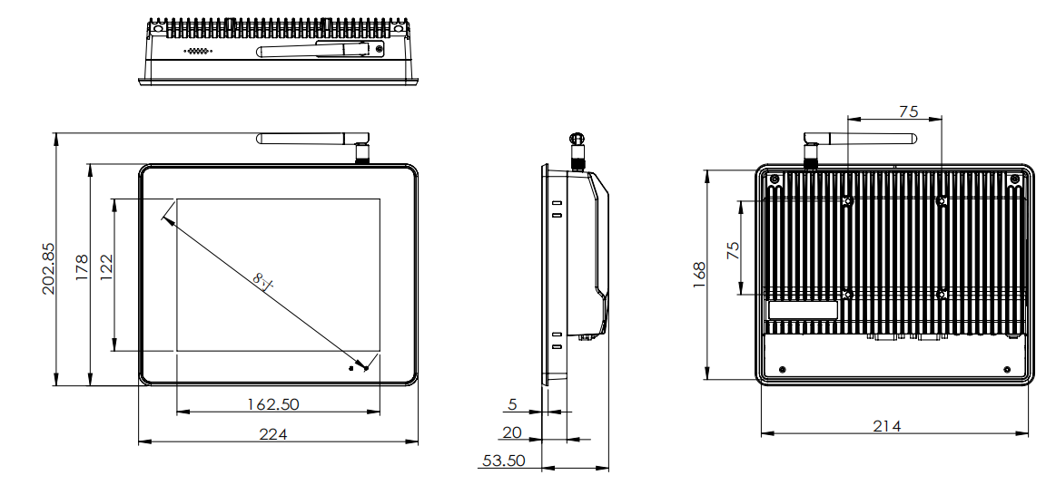

**10.Dimensions:**